MONSTER THE LOCH: INFORMATION PACK
- Saturday 19th September 2026 -

Important information to assist your preparation for and enjoyment of the event. Please read carefully and email any queries asap to monster@monstertheloch.com. Please note there are maps at the end of the document of the start/finish locations.

- Safety Video - available here: http://monstertheloch.com/rules-and-regulations Please take the time to watch this online safety video. Though there will be a safety briefing on the day for captain/cox of all crews, we ask that every competitor watches this video prior to the event. Participants’ safety and wellbeing is of utmost priority and we thank you for your cooperation.

- Participation Waiver – the participation waiver will be sent via email to all competitors to read, and then sign via Bolo forms. Please ensure that we have the names and email addresses of all of your crew. All competitors must have signed the waiver to be able to participate on the day. Please note that parents must complete the parental consent form for participants under the age of 18 years – (please let us know if you require the waiver for <18s)

- Race Direction – race direction will likely be from Fort Augustus towards Dores. THIS WILL BE CONFIRMED ON THE WEBSITE ON FRIDAY 18th SEPTEMBER AT 1200.

- Race Start time - The big race start will be at 1000, but this will depend on the weather we may move it forward by 1hr. Start time will also be confirmed on Friday 18th September.

- Registration – Please register your attendance at the Registration Tent at the starting field from 3.00pm-6.00pm on Friday 18th September and from 7.00am on Saturday 19th September. All competitors must have signed the participation waiver to be allowed to complete registration. At registration you will be given 2 numbers to wear whilst racing to allow for your time to be recorded. All crew members will be given Monster wristbands which they must keep safe to enable them to collect medals and competitor t-shirts at the finish. You will also be given ticket(s) for return journeys at this time.

- Boat Drop Off - Due to the extremely wet weather, vehicular access to the Fort Augustus field will be limited. Prepare to walk all small boats down from the top of the field. Larger boats on trailers will be marshalled onto the field. Please follow staff instructions and do not stay longer than necessary. Further instructions may follow. The gate to the field will be locked, and drop off times will again be from 3.00pm – 8.00pm on Friday 18th September and from 7.00am on Saturday 19th September. YOU WILL NOT BE ABLE TO DROP VESSELS OFF OUTSIDE OF THESE TIMES. We would recommend that if you drop off a boat on Friday, you then take the trailer to the finish immediately in preparation for loading after the event.

- Parking – At the Fort Augustus end, there is no strictly no parking on the field. A small amount of parking is available next to the field and will be signposted. This is reserved for those people involved in lifts/collecting fellow crew members from the finish. Otherwise please use the public car parks in Fort Augustus which are a short 10 minute walk, or alternatively get lifts with fellow crew members.

DO NOT PARK ON VERGES OR OBSTRUCT TRAFFIC - YOU ARE LIKELY TO BE
TICKETED!! PLEASE ARRIVE EARLY ENOUGH TO PARK IN TOWN. IT IS YOUR
RESPONSIBILITY TO PARK LEGALLY AND CONSIDERATELY.

At the Dores End, parking is available at the BOTTOM of the event field and will be signposted. Only boat trailers/vehicles that are essential to the event travel are able to park at the top of the field.

- Toilets and Changing – There will be portaloo toilets at both the start and finish. There will be limited changing facilities in tents at the start and finish.

- Luggage Transfer – If required, luggage will be transported from the start to the finish in designated transport manned by event staff. Please note belongings are left at your own risk and Rowing Centre UK Ltd. and the Event Staff do not take any responsibility for any loss/damage/theft that occurs.

- Safety Briefing – there will be a short safety briefing for captain/cox of each crew at 08:30am in front of the registration event. This is in addition to the online safety video.

- Health and Safety – There will be qualified first aiders to support on and off the water. There will be a fleet of safety boats coordinated by The adventure scouts covering the event. It is imperative that competitors heed Safety Boats and Event Staff advice/instructions at all times.

- Refreshments – We will have Caterers preparing food on Friday night at the Fort Augustus Field, providing Pasta and Curry including vegetarian and vegan options. Saturday Morning they will provide breakfast, tea and coffee. They will also provide after race feast and both soft and alcoholic drinks. Please purchase your food through the website before the race. There will be no other food vendors at the finish.

- Return Transport – limited transport is available to allow people to return to the start line in a ratio of 1 coach journey ticket per 4 competitors. There will be 2 coach journeys: 2:30pm for early finishers and 5:00pm for later finishers. Please let the team know by email if you intend to use this facility. We encourage lifts with friends and family where able.

- Distribution of Shirts and Medals – you will require your Monster wristband to collect medals and competitor T-shirts. Please collect these from the stand at the finish field.

- What 3 Words Locations – we have listed below important locations using the “what 3 words” system. You simply go to what3words.com website and enter the 3 words and the precise location ie the middle of a field(!) will be located. There are also maps following this.

- Fort Augustus Event Area: winemaker.elect.relaxed
- Limited Parking@Fort Augustus: shared.automate.seaweed
- Public Parking in Fort Augustus: decide.bluff.nail
- Dores Event Area: strongman.coarser.super
- Dores Entry Gate for Vehicles: hoops.backup.marble

- Important Contact Numbers - Please be aware that signal is variable along the loch, and that is why we will be relying on our safety vessels and radio contact. However, should you need to contact event staff during the race via telephone, the number is 07540 637211.

MAP OF FORT AUGUSTUS END

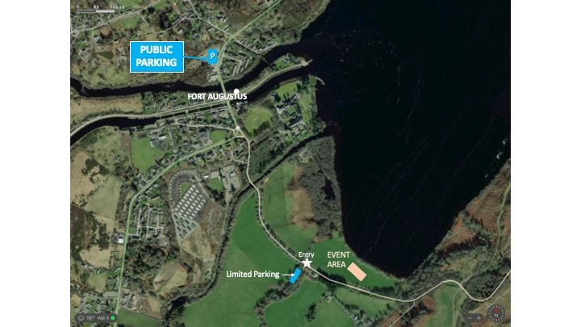

MAP OF DORES END
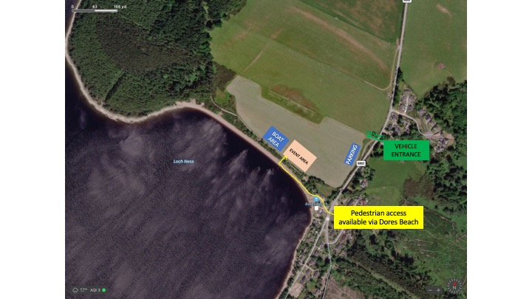

LOCATION OF THE FISHERY IN RELATION TO THE DORES END

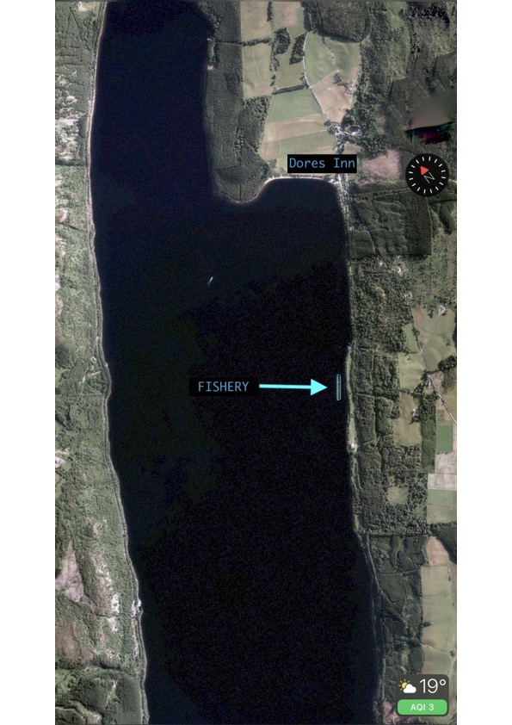

WE LOOK FORWARD TO SEEING YOU ON THE
19th SEPTEMBER TO TAKE ON NESSIE!!!

www.monstertheloch.com
monster@monstertheloch.com

